

# Uniden SS E45

## Type of device: Landline - Cordless

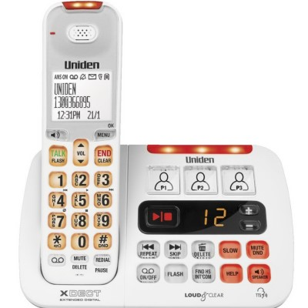

Button Type : Physical Keypad

Average Price : $116 as of 19 12 2019

## Accessibility Features:

### Cognitive

Photo Telephone List

### Hearing Impairment and Deaf

* Hearing Aid Telecoil Coupling

Visual Alerts - Incoming Calls

### Vision

* Battery Alert - Audible
* High Contrast Mode
* Key Marker – Raised '5'
* Key Numbers - Standard Layout

Key Press - Vibration or Click

### Physical

* Automatic Answer
* Guarded/Recessed Keys
* Physical Dialling Keys

Speaker-phone option

## How and where to get it from?

You can buy this phone from [Harvey Norman](https://www.harveynorman.com.au/catalogsearch/result/?q=Uniden+SSE45), [JB HI-FI](https://www.jbhifi.com.au/products/uniden-ss-e451-sight-sound-twin-cordless-phone?q=Uniden%20SSE45), [Officeworks](https://www.officeworks.com.au/shop/officeworks/p/uniden-sse45-1-cordless-phone-unsse451wh?q=Uniden%20SSE45&view=grid&page=1&sortBy=prod-product-wc-bestmatch), [Bing Lee](https://www.binglee.com.au/search?q=Uniden%20SSE45&page=1&limit=36&sort=relevance&mode=grid&type=products), [The Good Guys](https://www.thegoodguys.com.au/uniden-cordless-phone-twin-pack-sse451), and other retailers.

## More information is available on:

[Uniden SS E45 Web Page](https://uniden.com.au/product/ss-e45/#1493714178990-2a6cd7e5-3597)

[Uniden SS E45 Manual (Download)](https://uniden.com.au/wp-content/uploads/2017/07/SSE_45_OM.pdf)

[Uniden SS E45 Product Range (Download)](https://uniden.com.au/wp-content/uploads/2017/06/Uniden_SSE_ProductRangeFlyer-web.pdf)